**INVESTIGATION OF S- AND R-PROCESS NUCLEI USING NEUTRON CAPTURE REACTION**



Supervised by : Submitted by:

Dr. Samit K. Mandal Rashika Gupta , M.Sc Physics (Final)

Department of Physics and Astrophysics Department of Physics and Astrophysics

University of Delhi University of Delhi

**Candidate’s Declaration**

I hearby declare that the work , which is presented in this project report , entitled

**“Investigation of s- & r- process nuclei using neutron capture reaction**” Submitted in the Department of Physics and Astrophysics , University of Delhi ,India is carried by me.

(Rashika Gupta)

M.Sc(Physics)

Department of Physics and Astrophysics

University of Delhi.

**Certificate**

This is to certify that dissertation project entitled : **“Investigation of s- & r- process nuclei using neutron capture reaction”** submitted in the Department of Physics and Astrophysics , University of Delhi , India , is an authentic record of work carried out under my guidance.

Dr.Samit K.Mandal

Department of Physics and Astrophysics

University of Delhi.**Acknowledgement**

I would like to express my special thanks and deep sense of gratitude to my guide Dr. Samit K. Mandal sir for the support and guidance he showed me throughout the dissertation which helped me a lot. I would also like to thank Dr. Unnati Gupta who had constantly helped me during the performance of experiment. I learnt and understood so many new things. I am sure this work wouldn’t have been possible without their guidance.

I would also like to thank the laboratory staff who contributed in one way or the other in the course of dissertation and helped me in finishing the dissertation within the limited time.

I am also thankful to my parents and friends for their constant support and encouragement.

(Rashika Gupta)

**Abstract**

The elements like hydrogen, helium, carbon, oxygen exist in the star. They are formed because of the gravitational effect and the nuclear reaction happening in the star and ceases when iron is formed since, it has the highest binding energy per nucleon. But, the traces of the heavy elements like gallium, lead, zinc are also found. These heavy elements are formed due to the neutron capture by the nuclei. Each of these elements have a specific neutron-capture reaction.

In the present work, we tried to investigate the neutron capture cross-section by Mg and Gd. The samples of naturally available magnesium and gadolinium were irradiated in the neutron source facility available in the Department of Physics and Astrophysics, University of Delhi. The number of counts was recorded for the irradiated sample using NaI scintillator and HpGe detector.

The spectra obtained were analysed and the half-life of 27Mg isotope was determined using NaI scintillator and HpGe detector. An attempt was made to determine the neutron-capture cross-section for 27Mg and 159Gd. The background radiation near the experimental set up was investigated.

**Content**

1. Introduction. 9

2. Motivation for the experiment. 14

3. Experimental Setup. 16

i) Neutron Source (Ra-Be). 16

ii) Detectors. 17

iii) Electronics. 20

4. Observations. 22

5. Results. 31

5. Summary. 43

6. Reference 44

**List of tables**

|  |  |
| --- | --- |
| Table 2.1 Properties of isotopes og magnesium | 14 |
| Table 2.2 Gamma energies and their Intensity | 14 |
| Table 2.3 Properties of isotopes in gadolinium | 15 |
| Table 5.1 Calibration of NaI scintillator | 31 |
| Table 5.2 Time elapsed and area under the spectrum of 27Mg using NaI scintillator | 32 |
| Table 5.3 :Energy used along with the channel and FWHM for calibration of HpGe detector | 34 |
| Table 5.4 Time elapsed and area under the spectrum of 27Mg using HpGe detector | 35 |
| Table 5.5 Peaks in background spectrum and their source | 39 |

**List of figures**

|  |  |
| --- | --- |
| Fig 1.1 History of Universe | 9 |
| Fig 1.2 Binding Energy per nucleon | 10 |
| Fig 1.3 Plot of abundance of elements in the star | 11 |
| Fig 1.4 s-process in the nuclei | 12 |
| Fig 1.5 s-process depicted in chart of nuclides | 13 |
| Fig 1.6 Chart of Nuclide showing the path of r-process | 13 |
| Fig 3.1 Block diagram of the experimental setup | 17 |
| Fig 3.2 Working of scintillator and Photomultiplier Tube | 18 |
| Fig 3.3 NaI Scintillator detector used in the laboratory | 18 |
| Fig 3.4 HpGe detector used in the laboratory | 19 |
| Fig 3.5 Multi Channel Analyser | 20 |
| Fig 3.6 Block diagram of the experimental setup | 21 |
| Fig 3.7 HpGe detector used in the laboratory | 21 |
| Fig 4.1 Signal from the preamplifier | 22 |
| Fig 4.2 Signal from the amplifier | 23 |
| Fig 4.3 Decay scheme of 137Cs | 24 |
| Fig 4.4 Spectrum of 137Cs | 24 |
| Fig 4.5 Decay scheme of 22Na | 25 |
| Fig 4.6 Spectrum of 22Na | 25 |
| Fig 4.7 Decay scheme of 57Co | 26 |
| Fig 4.8 Spectrum of 57Co | 26 |
| Fig 4.9 Decay scheme of 60Co | 27 |
| Fig 4.10 Spectrum of 60Co | 27 |
| Fig 4.11 Spectrum of 137Cs from HpGe detector | 28 |
| Fig 5.1 Calibration cure for NaI scintillator | 31 |
| Fig 5.2 Graph between ln(area under the spectrum) vs time elapsed for 27Mg using NaI scintillator | 32 |
| Fig 5.3: Spectrum of total number of counts for 27Mg using NaI Scintillator | 33 |
| Fig 5.5 Graph between ln(area under the spectrum) vs time elapsed for 27Mg using HpGe detector | 35 |
| Fig 5.6 Spectrum of counts of 27Mg using HpGe detector | 36 |
| Fig 5.7 Spectrum of total counts of 159Gd using HpGe detector | 37 |
| Fig 5.8 Spectrum of total number of counts for 159Gd ,27 Mg and background using HpGe detector | 38 |
| Fig 5.9 Spectrum of total number of counts of background for 1573 s using HpGe detector | 39 |
| Fig 5.10 Closer view of the spectrum of total counts for background and sources | 40 |
| Fig 5.11 Closer view of the spectrum of total counts for background and sources showing twin neutron capture ny Ge in HpGe | 41 |
| Fig 5.12 Showing the common peaks as observed in the spectrum of sources and background in the HpGe detector | 42 |

**Introduction**

Evolution of the Universe started with the big bang after the first second, protons and neutrons were created and during first three minutes Hydrogen, Helium and Lithium nuclei were created, leading towards cooling of the universe to form stars and galaxies to the Universe that we know now.

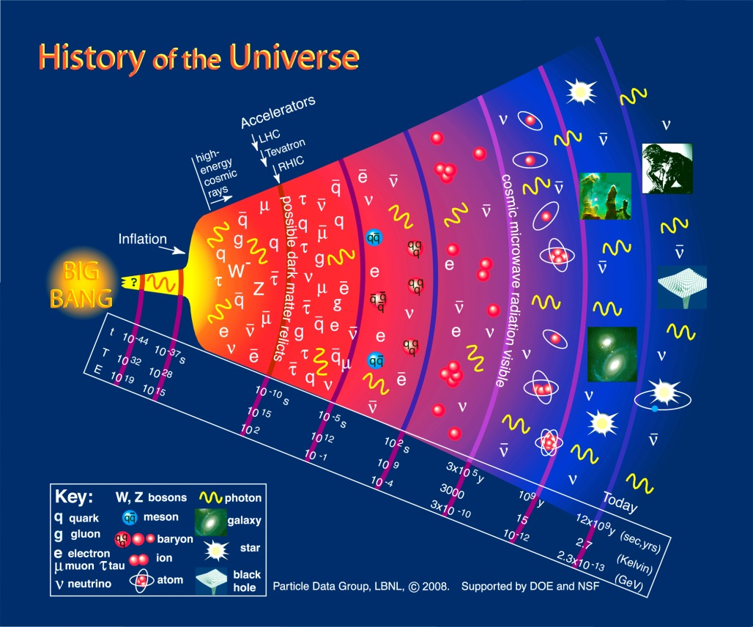

Fig1.1: History of Universe (Source: <http://www.particleadventure.org/>)

In the galaxy, the star begins from the cloud of hydrogen. When it contracts to a certain volume under its own gravity the energy and density of the star increases, this high energy leads to the burning of hydrogen to helium. However, the helium is consumed in the central region of a star as a result, the mass of the convective core decreases. Nuclear energy generation in the core is gradually replaced by the release of the gravitational energy, and helium burning begins to occur in the outer shell. After the complete exhaustion of helium, the temperature of the core increases owing to its gravitational contraction until the onset of carbon burning[1]*.* Carbon burns to oxygen which further burns to silicon and then to iron. It can be explained from the binding energy per nucleon curve of the elements as shown in fig.2. It can be observed that the increase in binding energy corresponds to release in energy as nuclei combine to form other element whose binding energy is higher. As can also be seen, light elements such as hydrogen release large amounts of energy (a big increase in binding energy) when combined to form heavier elements in the process of fusion. Similarly, the heavy elements, to attain the stability would release energy when they are converted to the lighter nuclei through beta/ alpha decay [2].

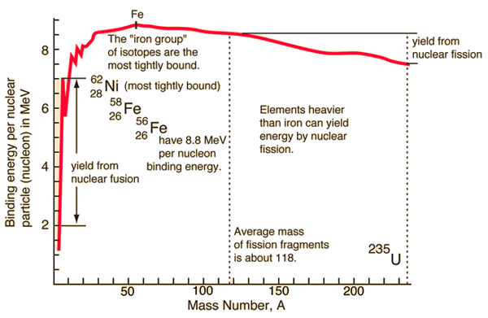

Fig 1.2 : Binding Energy per Nucleon (Source : Hyperphysics )

To form the heavy element more energy needs to be added in the system which is not possible. Therefore, at this stage all the burning process stops and gravitation causes the star to contract making it dense which eventually explodes to the supernova. The star with mass less than 8 times the mass of sun, never ignite Carbon forming red giant, while other after going through the competition between gravity and nuclear processes ultimately burns to supernova .

What we want to know is how heavy elements were formed in the universe? The process that happens at the scale of nucleus tells us what happens at the scale of the universe[2]. Let us consider the star we know best about, the sun. It is 150 billion Kms away from earth with mass = 1.989*1030 while about 67 elements have been detected in the sun. The hydrogen contributes to 0.7 and helium 0.2 of the solar mass respectively. The trace of other elements like oxygen, carbon, nitrogen, silicon, magnesium, neon, iron etc., have also been found[3]. It can be shown that from fig. 3, universe is not just made of elements lighter than iron. Plot[fig. 3] of abundance of elements in universe shows the existence of elements heavier than iron suggesting multiple processes are responsible to produce these elements.

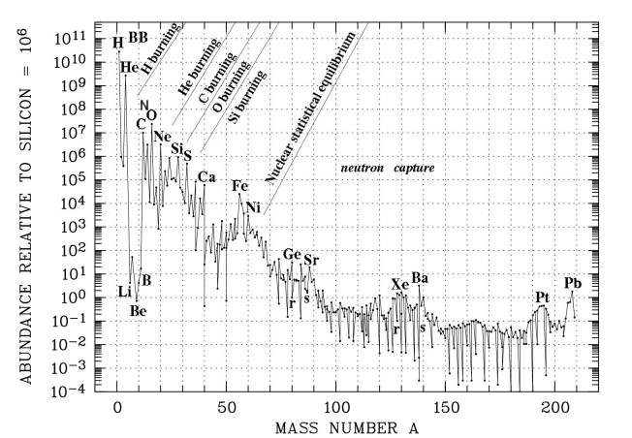

Fig 1.3 : Plot of abundance of elements available in the Universe vs the mass no. [Source :www. universe – review .ca]

The heavy elements can’t be created during the burning stage of the star. Massive elements can be created by different processes like; via addition of particles, collision or merging of particles. Since, neutrons have no electric charge they can enter a nucleus more easily than positively charged protons, which experience coulombic repulsion[2]. The capturing of neutron is the most probable process. In this process, the atomic mass of the nucleus increases by one. A neutron in the new nucleus decays to proton by a beta minus increasing the atomic number. Further, on the basis of rate of capture it can be divided into two categories:

1. Slow neutron capture : s – process ,
2. Rapid neutron capture: r – process.

**a) s-process:**

In the s-process, the rate of neutron capture by [atomic nuclei](https://en.wikipedia.org/wiki/Atomic_nucleus) is slow relative to the rate of radioactive beta-minus decay. In terms of time scale it can be said, that time until a neutron is captured is longer than the half-life of nucleus. At present it is happening in the Betelgeuse, in Orion constellation. This process produces stable isotopes by moving along the valley of [beta-decay stable isobars](https://en.wikipedia.org/wiki/Beta-decay_stable_isobars) in the [chart of isotopes](https://en.wikipedia.org/wiki/Table_of_nuclides). The extent to which the s-process happens in the star depends on its degree to produce neutrons. The main neutron source reactions are: 22Ne(α,n)25Mg and 13C(α,n)16O ,producing heavier elements eventually reaching 209Bi[4].

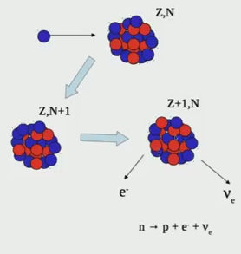

Fig 1.4 : s-process in the nuclei

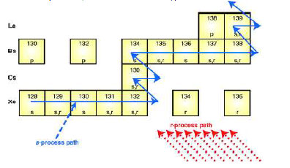

Fig. 1.5 : A small portion of the chart of the nuclides[5], illustrating isotopes built by the three basic processes. Only stable isotopes are shown, and letters indicate the processes that can contribute to these isotopes.

**b) r – process**

In the r– process, neutron capture takes place rapidly, which is different from the s-process in neutron flux density. The elements higher than iron are formed majorly because of the r-process. In terms of time scale, a neutron is captured by nuclei prior to its decay (half –life). In this case, the nucleus captures multiple neutrons before it undergo beta decay. It usually happens in the environment with a lot of neutrons and ejected material and should already have iron. The several possibilities of r-process to happen is when a neutron star mergers and “wind” close to the core of core – collapse supernova.

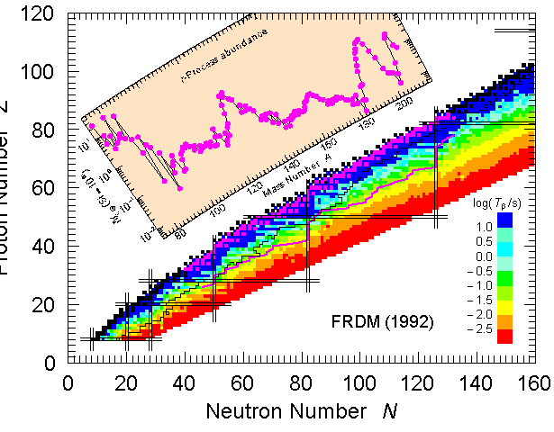

**Neutron Number (N)**

**Proton Number Z**

Fig. 1.6 : Chart of Nuclide depicting r- process path (Source :www.nupecc.org)

The beta-decay time-scales of radioactive neutron rich nuclei is shown if fig.6. It can be observed from fig. 6 that these nuclei are shifted by many units toward neutron richness in the chart of nuclides.

**2. Motivation for the experiment**

The investigation of exotic elements plays an important role to understand the astrophysical processes, responsible for the energy production and formation of heavy elements in the Universe, some of these elements do not exist on earth due to the extremely short half-life. The study of these elements can only be performed by producing them in laboratory through nuclear reactions. It is well known that Mg, Al, Ga and heavy elements like Se, Br, Ag, In, Gd, Pb etc., are found in the stars. These elements are formed in the s-process or r-process followed by beta/alpha decay forming a stable nuclei. Each of these elements has a particular neutron capture cross section. Therefore, it will be interesting to investigate the neutron capture reaction mechanism for the above nuclei. In the present experiment, an attempt has been made to understand the capture – reaction mechanism by investigating Mg and Gd nuclei. The gamma rays from the above two nuclei was measured to study the above nuclei.

The isotopic abundance in naturally available Magnesium, the mode of their decay after the neutron capture and their half- life given in table 1 while the decay properties of the 26Mg are listed in table2.

Table 2.1 : The properties of isotopes of magnesium. [5]

|  |  |  |  |  |
| --- | --- | --- | --- | --- |
| **Isotope** | **Abundance(%)** | **Decay** | **Half -Life** | **Cross-section(mb)[11]** |
| 24Mg | 78.99 | Stable | - | 52 |
| 25Mg | 10.00 | Stable | - | 182 |
| 26Mg | 11.01 | Beta - | 9.458(mins) | 34 |

.

Table 2.2: Gamma Energies and Intensity of beta decay of 26Mg [5]

|  |  |
| --- | --- |
| **Energy (keV)** | **Intensity (keV)** |
| 170.82 | 0.86 |
| 843.76 | 71.8 |
| 1014.52 | 28.2 |

The isotopic abundance in naturally available in Gd, the mode of their decay after the neutron capture and their half- life given in table 3 while the decay properties of the 159Gd are listed in table 4.

Table 2.3:The properties of isotopes present in naturally available Gadolinium [5].

|  |  |  |  |
| --- | --- | --- | --- |
| **Isotope** | **Abundance(%)** | **Decay** | **Half –Life** |
| 154Gd | 2.18 | Stable | - |
| 155Gd | 14.8 | Stable | - |
| 156Gd | 20.47 | Stable | - |
| 157Gd | 15.65 | Stable | - |
| 158Gd | 24.84 | Beta | 18.497 h |
| 160 Gd | 21.86 | Stable | - |

158 Gd (n0, gamma) 159 Gd with cross–section being 2.0 barn[12] which beta decays to 159 Eu with the characteristic gamma ray of 363.5 keV of intensity 11%[5].

**3.Experimental Setup**

The present experiment was performed in the M.Sc. laboratory in Department of Physics and Astrophysics, University of Delhi, Delhi. The natural samples of magnesium and gadolinium were used for the activation. The irradiations of the samples were carried at the neutron source facility. After the irradiation, the samples were placed on the detector to measure beta decay half-life and neutron capture cross-section. The details of the neutron source and the detectors are given in the following:

**i) Neutron Source(Radium – Beryllium)**

In the present work, Radium –Beryllium (Ra-Be) was used as a neutron source. Radium is highly radioactive element with the most stable isotope being 226Ra has a half-life of 1620 years[5]. It decays to Radon gas accompanied by the emission of α-particles[2]. It undergoes the following reaction

226Ra → 222Rn + α

Q-value of the α-particle is 4.87 MeV[7]. The emitted α-particle interacts with the 9Be as per the given reaction:

9Be + α → 12C + n

Q-value of the above reaction is +5.71MeV [6]. Since, alpha particles are charged and massive, they are able to travel only certain centimeters in air and through solid before they are stopped because of the collision hence, only 1 in 104 reacts with beryllium nucleus. To maximize the number of neutrons produced a homogeneous dispersion of α- emitter is distributed throughout an infinite number of beryllium atoms. Some of the common choices of alpha emitter are 226 Ra, 227Ac, 239Pu. The choice between the emitter primarily depends on the basis of availability, cost and half- life. These sources have a longer half -life and can be used without any decrease in neutron intensity for years together.

These materials are usually safely encapsulated because of the large activities of the radioactive isotopes involved in the neutron sources. Therefore, the Ra-Be neutron source is sealed within two individually welded stainless steel cylinders. The setup used for our experiment is kept in the hot laboratory in the Department of Physics and Astrophysics, University of Delhi. It was brought by the University of Delhi in 1948 from abroad. At present it can decay 104 neutrons per second. For the irradiation of the samples of natural magnesium and gadolinium were kept on April 1, 2016 at 5:45 pm. The duration of the samples activation was 18 days.

**ii) Detectors**

To measure the intensity of gamma rays from the beta decay of the sample, two types of detectors were used namely, NaI scintillator and HpGe detector their details are given below:

**a) NaI Scintillator**

For the gamma ray spectroscopy of the experiment NaI (Tl) –Sodium Iodide (Thallium) Scintillation detector has been used. They tend to have the best light output and linearity. Because of the high Z of iodide it was favored the gamma spectroscopy since it goes as Z 3.5[6]. It is based on the principle that when a charged particle passes through the detector it produces luminescence which is detected by special light sensitive phototubes which converts light signal to electrical signal that is amplified by suitable electronics. In NaI crystal, alternate lattice sites are occupied by positive (Na+) and negative (I-) ions. Because of the strong electrostatic interaction between the ions the energy levels of the valence electrons come together to form valence band. There is a conduction band which is separated by a forbidden energy gap.

When a charged particle passes through the crystal, it transfers energy to an electron in the valence band, as a result electron moves from valence band to conduction band. The electron trapped in the conduction band subsequently some down to the valence band. And during this process, light is emitted in the form of fluorescence. The whole process occurs in the time scale of 10-8 s. Since the light emitted is of high energy it doesn’t lie in the visible region .To shift the spectra to the visible region thallium is added In NaI. Thus, the emitted fluorescent light escapes absorption in the crystal.

**Photomultiplier tubes:**

When these photons fall on the photocathode, photoelectrons are emitted. In a photomultiplier, a series of electron emitting surfaces called dynodes, are arranged. The presence of dynodes gives rise to the multiplication in the number of electrons which are finally collected at the anode.

Therefore, a scintillator detector must be connected with the photomultiplier to transform the light pulses produced in the former into electrical pulses which is further amplified and recorded by suitable electronic devices [8].

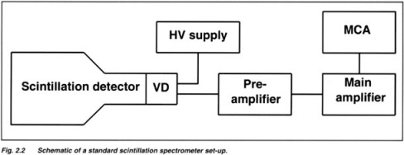

Fig 3.1: Block diagram of the experimental setup

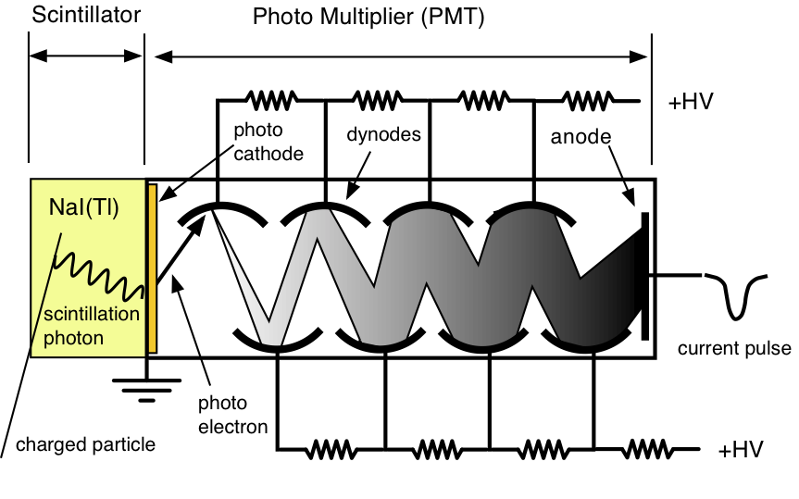

Fig 3.2: Working of Scintillator and Photomultiplier Tubes

.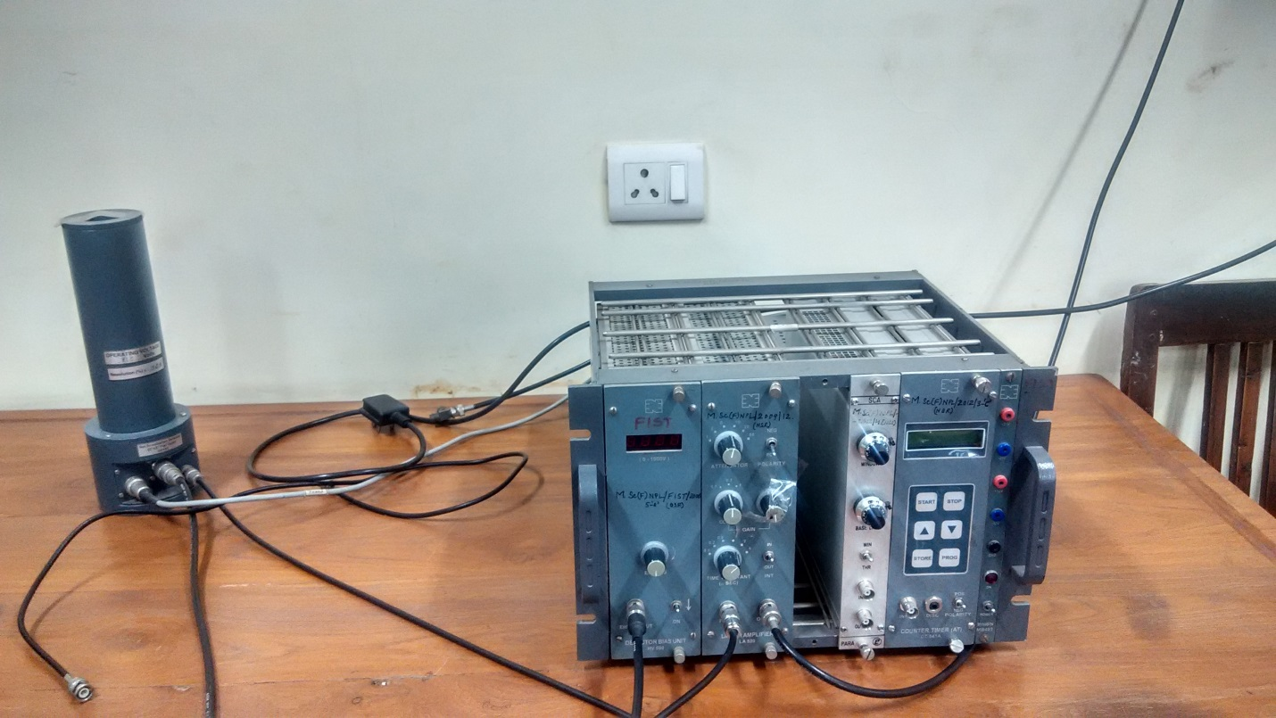

Fig 3.3: NaI Scintillator detector used in the laboratory

**b) High Purity Germanium Detector(HpGe)**

The radiations coming out of the nucleus, such as alpha, beta and gamma rays in the transitions, these outcoming particles, carry information about the properties of the nucleus. Hence, their detection and measurement are of prime importance in understanding the structure of nucleus. One such detector is a semiconductor detector. When a high energy radiation passes through the crystal it produces electron–hole pair. Some electrons in the valence band gain energy due to its interaction with the falling radiation and hence, they move to the conduction band. They are now free to move in the crystal under the influence of the applied electric field. The holes which are left behind in the valence band move freely and add to conductivity of the crystal, results in the change of the potential at one of the electrodes and is further converted to an electric pulse using suitable electronics. Since, these detectors result in large number of charge carriers for a given incident radiation than any other detector, they offer a better energy resolution, and a linear response. But, because of its compact size it is not as efficient as the inorganic scintillation detector. They cannot be operated at room temperature because of the smaller band gap. The temperature is reduced to 77K through the use of liquid Nitrogen.

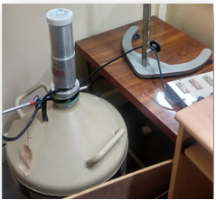

Fig 3.4 : HpGe Detector used for the experiment

**iii)Electronics**:

The signals were processed from the pre-amplifier and were fed to the amplifier which was further added to multi- channel analyser. The multi-channel analyser was connected to the computer. Their descriptions are as follows:

**a)Preamplifier:**

The function of preamplifier is to amplify the weak signals from a detector and derive it through a cable that connects the pre – amplifier with the rest of the experimental set up .They are usually kept as close as possible to the detector so as to minimize the pickup of stray electromagnetic field and cable capacitance which tends to decrease the signal to noise ratio.

**b)Amplifier:**

1. It amplifies the signals from the preamplifier and,

2. Shape the pulse to a convenient form for further processing.

**c)Multichannel analyser**

The amplified pulse from the photomultiplier is fed into electronic pulse height analyser MCA(multi-channel analyser ). In it the pulses in different amplitude ranges are simultaneously recorded and the numbers counted. They are interfaced with the Ethernet or USB. It uses a fast ADC to record incoming pulses in the either of the following ways:Pulse Height Analysis: In this mode, the pulses are counted based on the amplitude. The number of different amplitudes that are counted depends on the number of channels of the MCA but is normally in the range of few thousands. It is used to analyse the energy distribution in gamma spectroscopy[2].

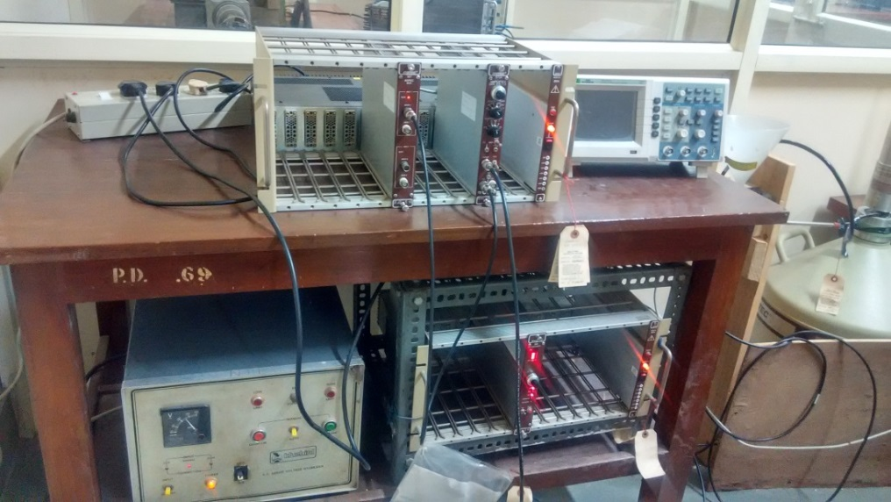

Fig 3.5: Multi Channel Analyser

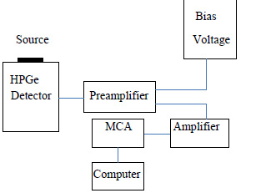

Fig3.6: Block Diagram of the Experimental Setup

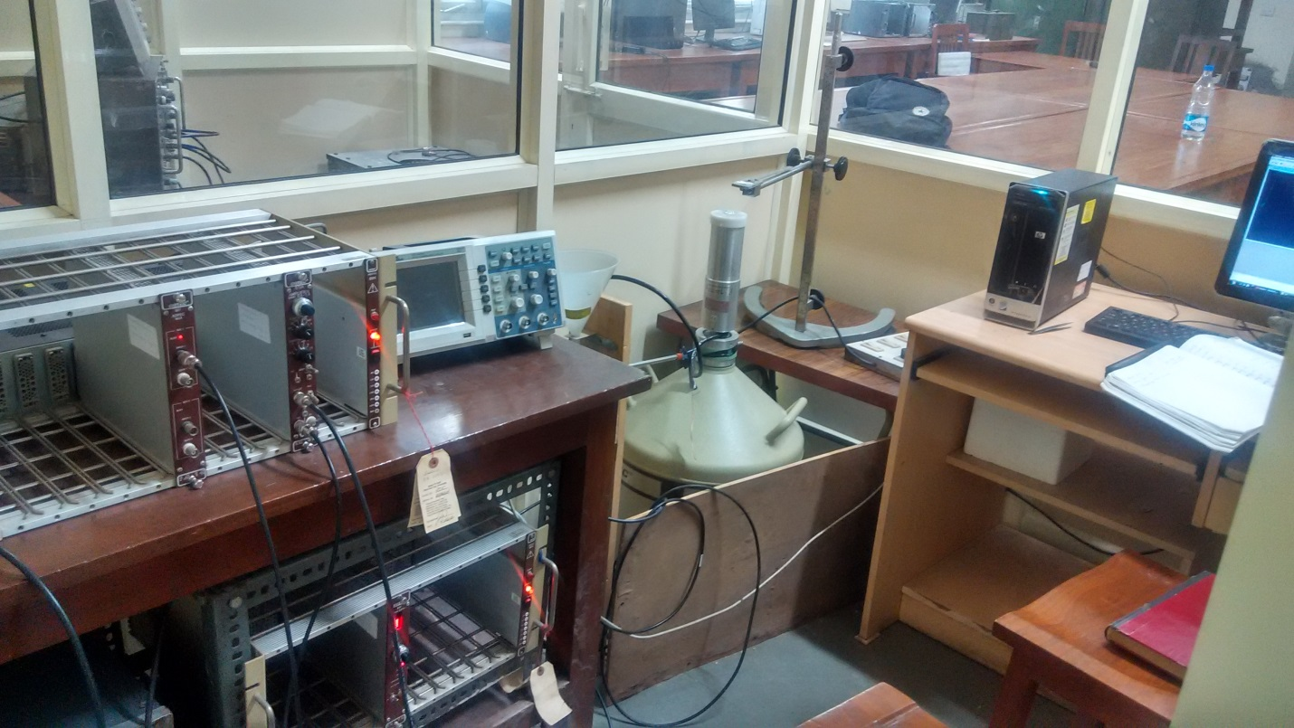

Fig 3.7 : HpGe detector used in the laboratory. On left is the MCA, then HpGe Detector which is cooled down by Liq.N2. The spectrum was observed in the computer

**4. Observations**

The experiment was performed using NaI Scintillator detector and HpGe detector. To determine the half -life of magnesium isotope the spectrum was obtained using both the detectors. To determine the neutron capture cross-section of Gd isotope, HpGe detector was used. The first phase of the experiment involved the usage of the NaI scintillator detector and the following steps were performed:

**4.1 Using NaI Scintillator**

First of all the voltage from the preamplifier was observed in the CRO(Cathode Ray Oscilloscope) and its rise time was found to 800ns.To further adjust the attenuator and gain of the detector, the signal from the amplifier was fed to the DSO(Digital Storage Oscilloscope). Since, the amplitude can show a maximum of 10 V signal. Since, the amplifier input can maximum take 10v as a input signal hence, the amplitude of 137Cs gamma signal has been set at 3V to accommodate unknown gammas upto 2 MeV. (as shown in fig 16) To get 3V signal from the amplifier , the preamplifier signal was attenuated 5 times and set amplified coarse gain at 0.3.The voltage applied to the PMT was 750V and amplifier shaping time constant was adjusted to 2 usec to get a good resolution.

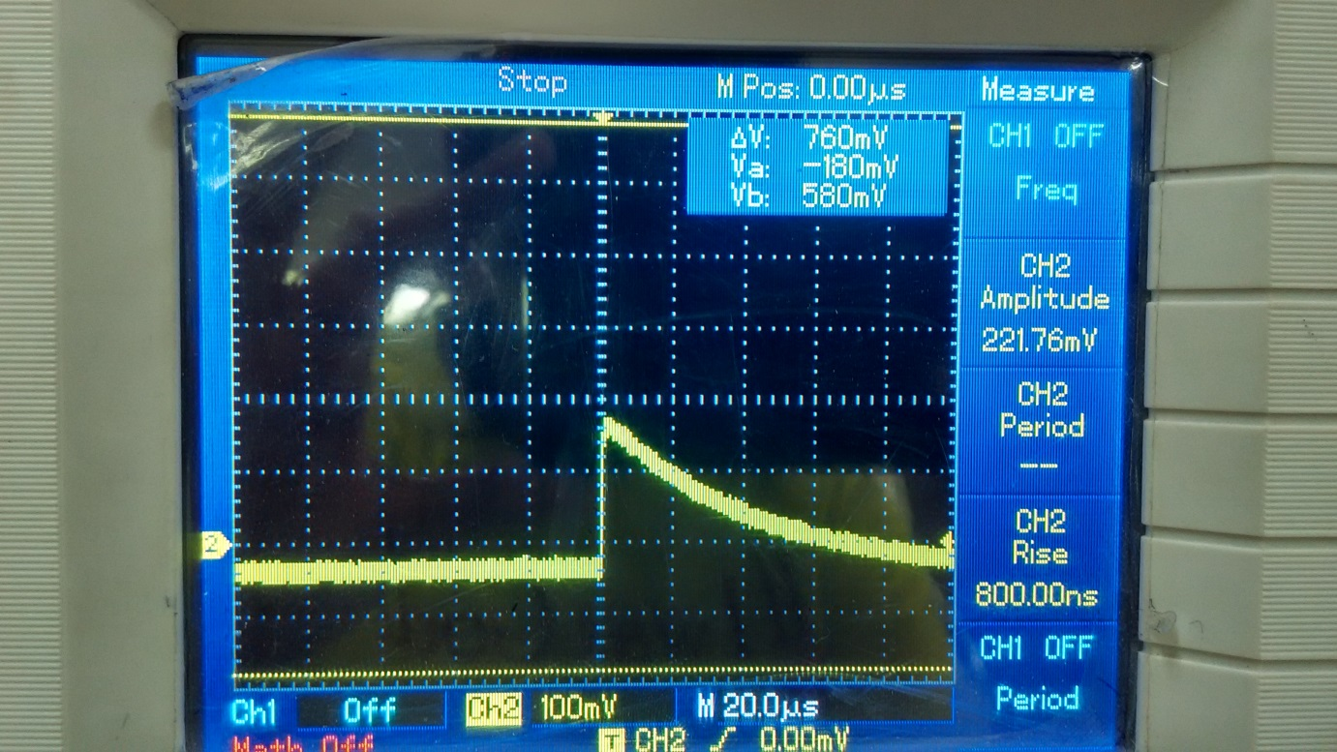

Fig 4.1: Singal from the pre – amplifier with rise time of 800ns as observed in the DSO.

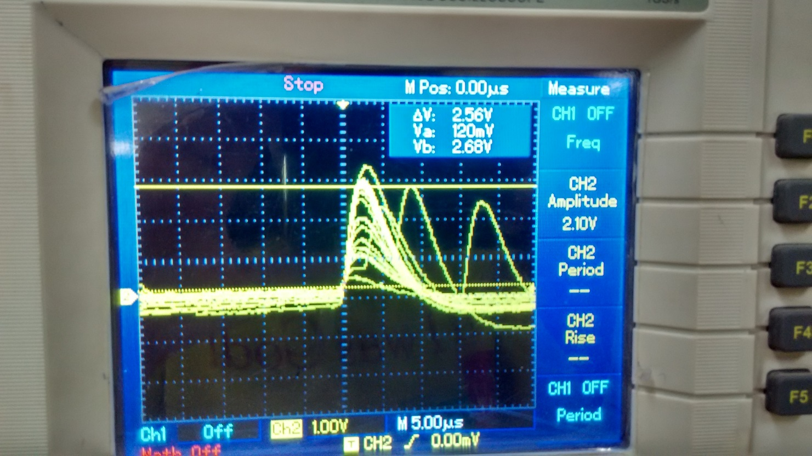

Fig4.2: Signal from the amplifier as observed in the DSO

The calibration of the detector was done using different known standard sources. This is required so that we can determine the relation between the energies of the gamma rays and the corresponding voltage or the channel number of the detector signal. It was done using following gamma sources 137Cs, 60Co, 57 Co and 22Na. The decay of gamma ray originated from these sources is shown in the fig no 4.3, 4.5, 4.7, 4.9 respectively. The source was placed at the detector and the counts were measured using MCA (model name ORTEC: 927 A, ASPEC MCA) [11]. The data was taken for 10 minutes. Typical spectrums obtained from the software are shown in fig no 4.4, 4.6, 4.8, and 4.10. The data file written by Maestro software [12] was converted in .spe file to plot the spectrum using CANDLE software [13]. The peaks were analysed and a Gaussian fit was done.

1.**137 Cs Source:**

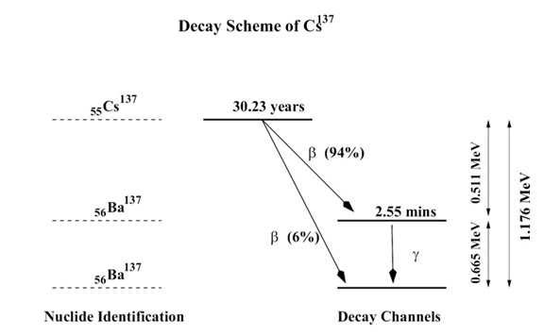

Fig 4.3 :Decay Scheme of 137 Cs.

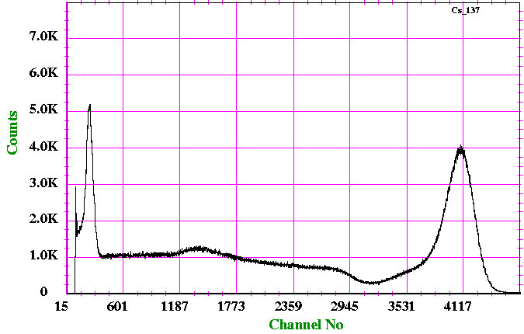Fig 4.4 : Spectrum of 137 Cs with the photopeak at Energy = 661.6keV

**2. 22Na Source:**

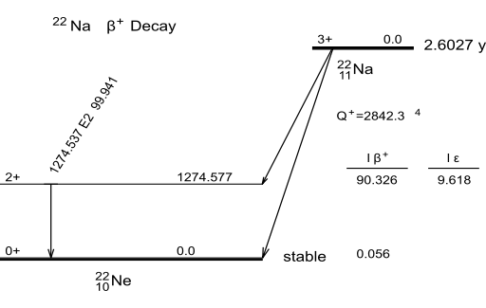

Fig 4.5 :Decay Scheme of 22Na.

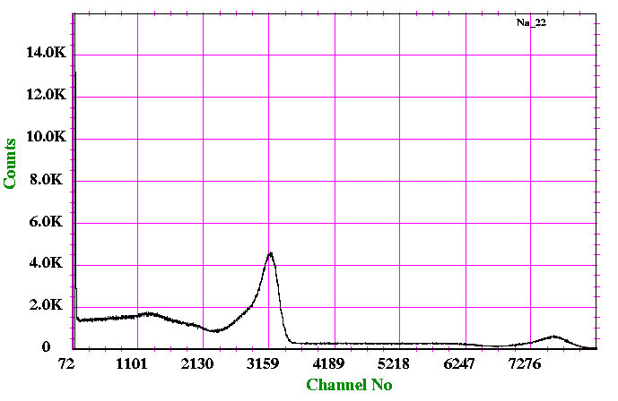Fig 4.6: Spectrum of 22Na photopeak at 551 keV and 1274.5 keV.

**3.57 Co Source**

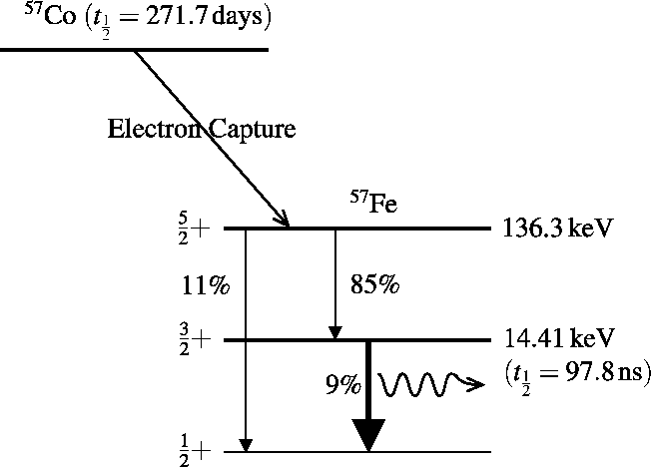

Fig 4.7: Decay Scheme of 57 Co.

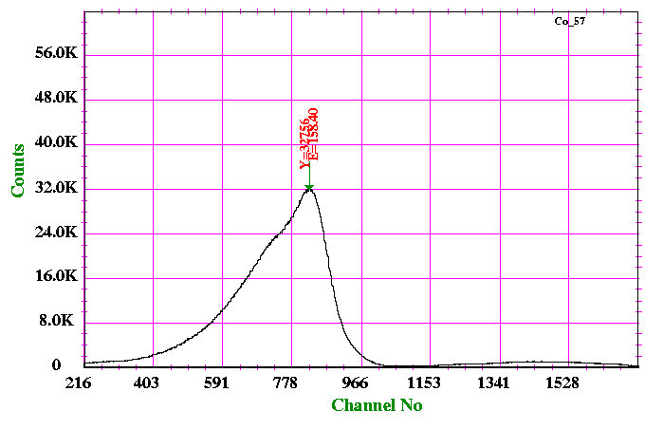

Fig 4.8: Spectrum of 57 Co E gamma – 136.3keV

**4. 60Co Source**:

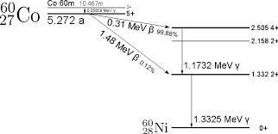

Fig 4.9: Decay Scheme of 60Co.

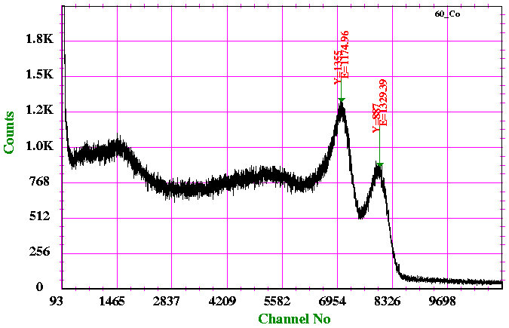

Fig 4.10: Spectrum of 60 Co

**Neutron activation measurement** The irradiated magnesium sample was placed in front of the NaI detector. Its activity was measured in regular interval by setting preset time of 2 minutes. The sample’s activity was measured for 1 hour 20 minutes. The cumulative counts under the spectrum were calculated. The analysis was done using the CANDLE[13]. The background radiation was extracted from the number of counts.

**4.2 Using HpGe Detector**

Electronics was adjusted after seeing the pulse on oscilloscope. The coarse gain was set a value of 50 to get the desired gamma energy, amplitude at 8.3 V and shaping time at 2 μsec to resolve the peaks with energy difference 2-3keV and Pole Zero was also adjusted to improve the resolution of the detector.

The calibrationof the detector was done using the 137Cs and 154Eu as the standard sources whose decay levels are given in fig. 4.3 and fig. 4.12 respectively. The counts were recorded for 5 minutes. The spectra was analysed using CANDLE[13].

**1. 137 Cs Source**

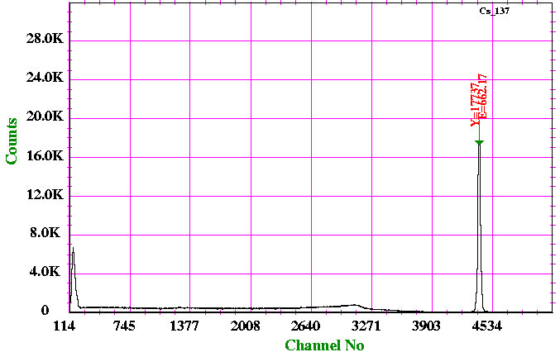

Fig 4.11: Spectrum of 137 Cs observed from HpGe detector.

**2. 154Eu Source**

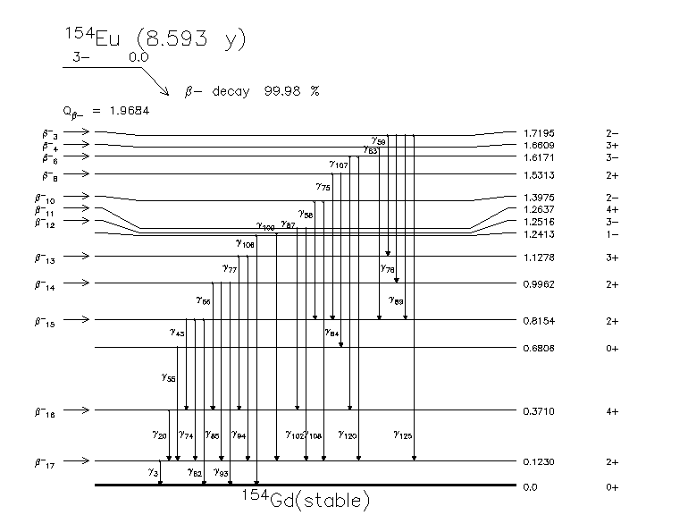 Fig 4.12 : Decay Scheme of 154 Eu

Table 4.1: Gamma ray energy observed and used during calibration.

|  |  |
| --- | --- |
| **Peak No** | **Energy (keV)** |
| 1 | 123.1 |
| 2 | 247.9 |
| 3 | 723.3 |
| 4 | 873.2 |
| 5 | 996.3 |
| 6 | 1004.8 |

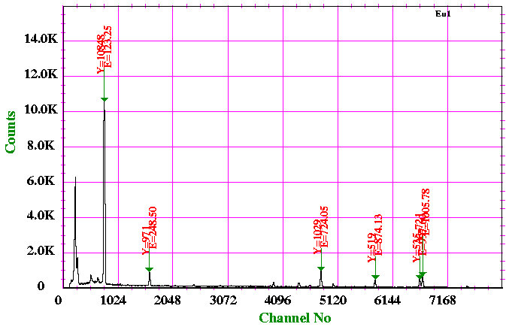Fig 4.13: Spectrum of 154Eu. The marked peaks were used for the calibration of the detector

After calibration the sample was taken out from the neutron source room and placed in front of the detector to record the spectra. The spectra was recorded at a regular interval of 2 minutes for 40 minutes. The area under the spectrum for every 2 mins was plotted against the running time. Same procedure was followed for the Gd sample.

**5.Result and Discussion**

In the present work, in order to measure the half-life of nuclei, the NaI scintillator was calibrated using various standard sources. The energies used for the calibration are listed in table 5.1 along with the channel number and FWHM. The graph were plotted using ORIGIN as shown in fig. 5.1. The first order polynomial was fit whose coefficients are 0.16291 and 23.9969

Table 5.1:Standard energies, Channel No and their corresponding FWHM used for the calibration of NaI scintillator.

|  |  |  |
| --- | --- | --- |
| **Channel No.** | **Standard Energy (keV)** | **FWHM** |
| 795 | 136.5 | 84 |
| 7055 | 1173.2 | 258 |
| 7985 | 1332.5 | 224 |
| 2936 | 511 | 119 |
| 4091 | 661.6 | 144 |



y = 0.16291*x+23.9969

Fig 5.1: Calibration curve for NaI Scintillator

In the next step, background was subtracted from the cumulative counts. The ln(area) vs time graph was plotted for Magnesium source. A straight line was fit with equation given by y = 6.89194-.00103*x. The error in the slope came out to be 0.04%. On comparing the coefficients with the formula N =N0e-  λt, slope of the equation gives the decay constant. The half-life = 0.693/  λ = 672.85 sec which is equal to 11m 12 s. The literature value of half-life of 27 Mg isotope is 9 m 27 s[5].

Table 5.2: Time elapsed and the area under the spectrum of 27Mg using NaI scintillator.

|  |  |  |  |  |  |
| --- | --- | --- | --- | --- | --- |
| **Time elapsed(sec)** | **Area** | **ln(area)** | **Time elapsed(sec)** | **Area** | **ln(area)** |
| 165.05 | 38764 | 6.79 | 1540.02 | 38380 | 6.23 |
| 326.07 | 38764 | 6.79 | 1690.04 | 38770 | 6.80 |
| 486.48 | 38681 | 6.69 | 1859.08 | 39328 | 7.28 |
| 603.01 | 38491 | 6.42 | 2002.09 | 38713 | 6.73 |
| 772.02 | 38538 | 6.50 | 2158.06 | 37970 | 4.58 |
| 921.03 | 38519 | 6.47 | 2311.01 | 38843 | 6.87 |
| 1073.05 | 38694 | 6.71 | 2474.04 | 38543 | 6.50 |
| 1233.08 | 38259 | 5.95 | 2632.02 | 38682 | 6.69 |



y = 6.89194-.00103*x

Fig 5.2 : Graph between ln(the area under the spectrum) vs time elapsed for 27Mg using NaI Scintillator.

The spectrum of total number of counts was analysed for 27Mg using NaI Scintillator.

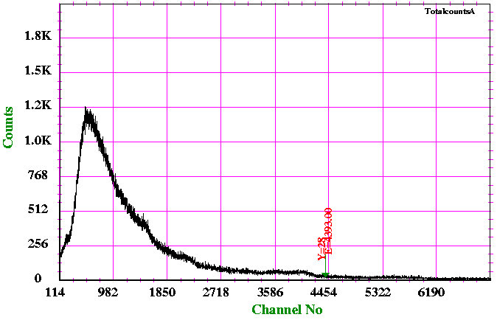

Fig 5.3: Spectrum of total number of counts for 27Mg using NaI Scintillator

**5.2) Using HpGe Detector:**

Calibration: Graph was plotted between Channel No at which photo-peak were obtained vs the standard energy using Origin. The first order polynomial was fit with x axis representing the channel no and y axis representing the energy corresponding to the given channel no.

|  |  |  |
| --- | --- | --- |
| **Channel No** | **Standard Energy(keV)** | **FWHM** |
| 4396 | 661.6 | 32 |
| 769 | 123.1 | 24 |
| 1611 | 247.9 | 25 |
| 4811 | 723.3 | 25 |
| 5820 | 873.2 | 25 |
| 6648 | 996.3 | 24 |
| 6706 | 1004.8 | 24 |

Table 5.3 :Energy used along with the channel and FWHM for the calibration of HpGe detector



y =0.148749*x+ 8.7124..

Fig5.4 : Calibration curve for HpGe Detector

The ln(the area under the spectrum) vs time elapsed graph was plotted for magnesium sample. A straight line was fit with equation given by y = 8.04891-.00126*x .The error in the slope came out to be 0.03%. On comparing the coefficients with the formula N0e-  λt , slope of the equation gives the decay constant. The half-life = 0.693/  λ =0.693/ 0.00126 = 550 sec which is equal to 9 m 10 s. The adopted value of half-life of 27 Mg isotope is 9m 27 s [5].

Table 5.4 : Time elapsed and the area under the spectrum of 27Mg using HpGe Detector.

|  |  |  |
| --- | --- | --- |
| **Time(sec)** | **Area** | **ln(area)** |
| 253.02 | 2566 | 7.85 |
| 481.25 | 1622 | 7.39 |
| 634.02 | 1349 | 7.20 |
| 782.01 | 940 | 6.84 |
| 927.03 | 1213 | 7.10 |
| 1079.09 | 1481 | 7.30 |
| 1240.08 | 389 | 5.96 |
| 1336.04 | 1198 | 7.08 |
| 1560.01 | 531 | 6.27 |
| 1712.04 | 1072 | 6.97 |
| 1880.01 | 1038 | 6.94 |
| 1911.01 | 752 | 6.62 |



Fig 5.5:Graph between ln(Area under the spectrum) vs time elapsed for 27Mg using HpGe detector

The spectrum of total number of counts was analysed for 27Mg and 159Gd using HpGe detector using CANDLE[13].

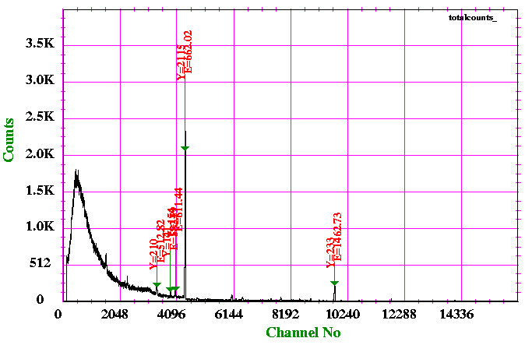

Fig 5.6 : Spectrum of counts of 27Mg recorded using HpGe Detector.

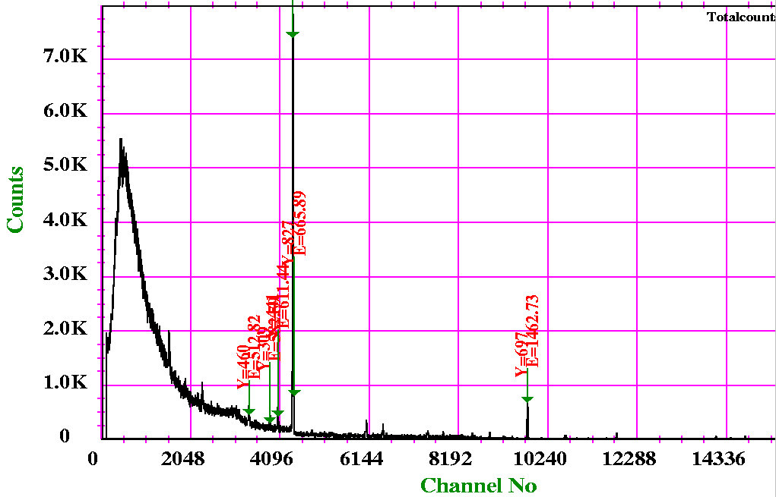

Fig 5.7: Spectrum of counts for 159 Gd recorded HpGe Detector.

Spectra was plotted for total number of counts over an elapsed time so as to determine cross–section3 of a neutron reaction for a given isotope which could be determined from area under the photo peak , i.e the total number of counts in the photopeak and the efficiency of the detector .From the literature, the neutron cross-section for 27Mg is 30 mb[11]which is sufficient enough to show the peak of a gamma energy , and for 154Gd it is 2.0 barn[12] which are quite high but because of a huge background radiation , we were unable to calculate the cross section. This can be seen from the comparison of spectrum of Mg, Gd and background, the gamma of a particular energy was suppressed under the background.

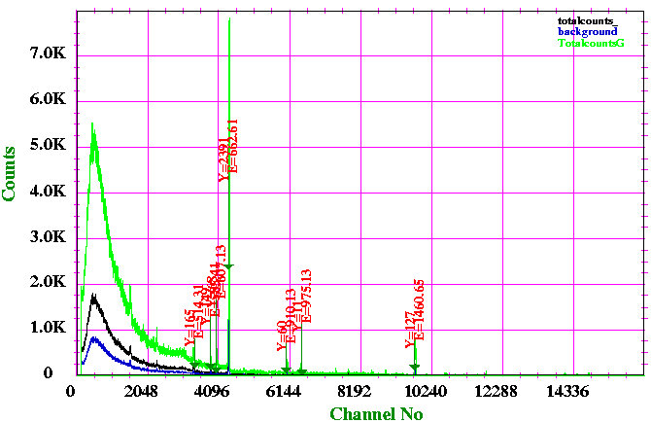

Fig 5.8: Spectrum of total number of counts for 159 Gd, 27Mg and background

using HpGe detector.

On analyzing the background spectrum, different peaks were identified which appeared to come from different sources. A prominent 137 Cs peak at 661 keV was seen in every spectrum which came from a source kept in a nearby experimental setup called Compton Scattering , which has Cesium whose activity wsa 200 µci. The other peaks could have come from the sources kept in a source room just near the experimental set–up. Because of the insufficient shielding, these gammas were also detected by the detector. In the spectrum of background peaks were identified and listed in the table.

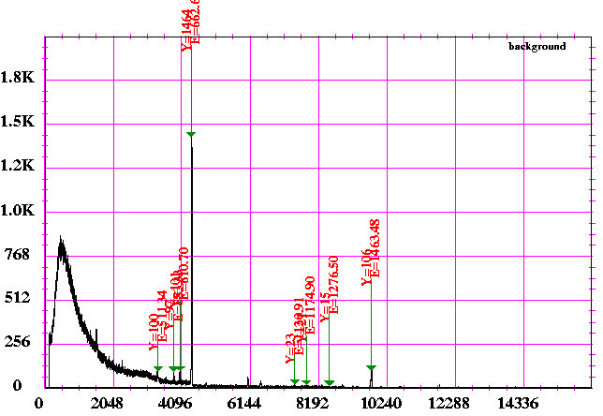Fig 5.9: Spectrum of total number of counts for background for 1573 seconds using HpGe Detector

Table 5.5: Peaks in the background spectrum and their sources

|  |  |
| --- | --- |
| Energy of the peak(keV) | Source |
| 511.69 | Annihilation peak |
| 584.09 | Neutron Capture by Ge in the detector |
| 610.32 | Neutron Capture by Ge in the detector |
| 662.74 | Cesium photo-peak from a near by setup |
| 1174.67 | 60Co from the source room |
| 1334.24 | 60Co from the source room |
| 1462.76 | 40 K from the bricks of the wall |

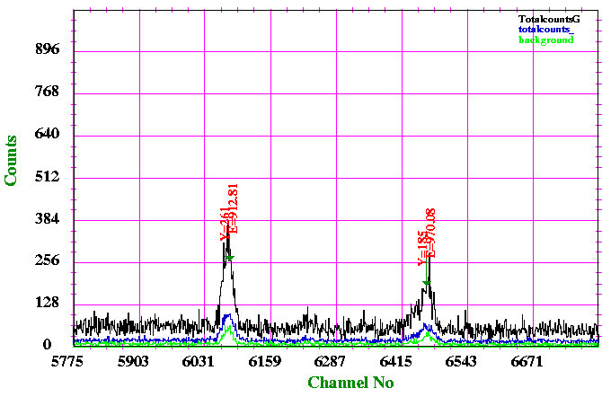

Fig 5.10: Closer view of the spectrum of total number of counts for background and the sources using HpGe Detector

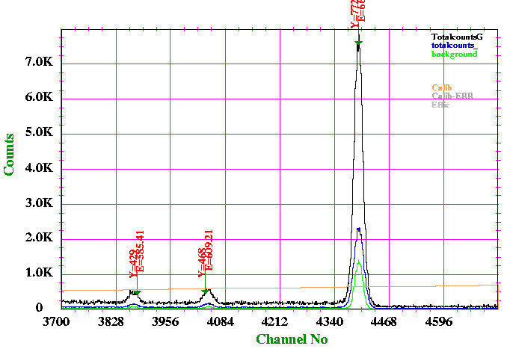

Fig 5.11 Closer view of the spectrum of total number of counts for background and the sources using HpGe Detector .The peaks can be identified in the background coming from twin neutron capture reaction by Ge in the detector and photopeak corresponding to Cesium.

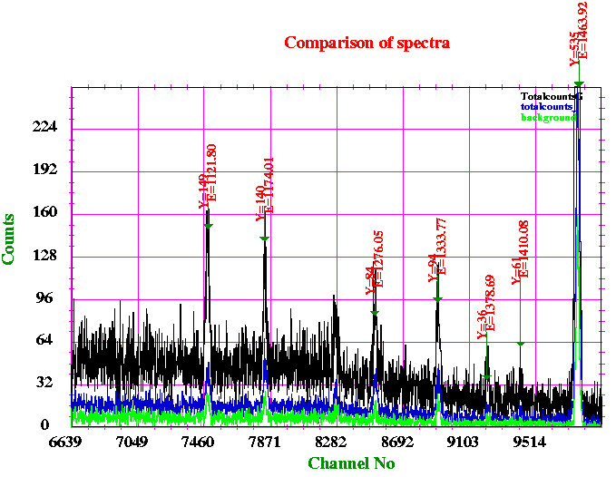

Fig 5.12: Showing the common peaks as observed in the spectrum of the sources and background in the HpGe detector.

**6.Summary**

The above experiment was performed to understand the neutron cross-section to explore the r and s–process nuclei formed during stellar evolution. The irradiated samples were prepared using natural magnesium and gadolinium. The samples were placed in neutron activation facility available in the University of Delhi. The samples were irradiated for 18 days. After the irradiation, the intensity of the gamma rays were measured. Using NaI scintillator and HpGe detector various gamma rays were detected.

The half-life of 27Mg source was extracted from the spectra recorded using NaI and HpGe detector are 11 m 12 s with error as 0.04% and 9 m 10 s with error 0.03% respectively. The adopted value of the half-life of 27Mg isotope is 9 m54 s[5].

An attempt was made to extract neutron induced cross–section by measuring the gamma ray intensity using HpGe detector. In this purpose background radiations were also measured. We observed a huge amount of background which somehow suppressed the gamma rays from Mg and Gd source. Hence, the background measurement for a longer duration will be helpful to understand the different sources of the background present in the vicinity of the experimental set-up which later on can be minimizes by appropriate shielding.

**7.Reference**

[1]. Progress of Theoretical Physics, Vol. 29, No.1, January 1963 ,Thermonuclear Reactions

in Stars Involving Heavy Ions ,up to the Formation of Iron Nuclei ,Hiroshi TSUDA,

Department of Nuclear Science, Kyoto University, Kyoto.

[2]. Wikipedia

[3]. http://www.knollslab.com/nuclides.html

[4]. Evolution of massive stars , Fabrice Fleurot

[5]. www.nndc.bnl.gov.in

[6]. Radiation Detection and Measurement , Third Edition, Wiley-India Edition, by F. Knoll

[7]. www.scientificsentence.net/Equations/Nuclear_Physics

[8]. Nuclear Physics by Ghoshal

[10]. Nuclear Reactions for Astrophysics by Thompson and Nunes.

[11]. Nuclear Physics A 102 (1967) 209-225 , P.Spilling et al.

[12]. Journal of the Korean Physical Society , Vol 59, No.2 , Aug-2011 pp 1932-1935 by J Lee

[13]. E.T. Subramaniam et al , Collection and Analysis of Nuclear Data using Linux

nEtwork(unpublished)

[14]. Synthesis of elements in star by Burbidge, Burbidge, Fowler and Hoyle, Reveiew of

Modern Physics, Vol 29, No. 4 , 1957.

[15]. Abundance of elements by Suess and Urey.